Abstract

Introduction:

Machine Learning (ML), having been utilized in various medical fields like radiology, cardiology, dermatology and mental health have brought great impact and success, in some cases outperforming the human specialists (Choy et al.,2018; Cabitza et al., 2018, Brynjolfsson & Mitchell, 2017). Especially in diagnosis, ML supported diagnosis is transforming healthcare by making use of abundant patient data to provide personalized and precise diagnoses (Bohr & Memarzadeh, 2020). In orthopedics, analyzing walking parameters by gait phase is essential to enable a deeper understanding of human movement and assistive device control (Farah et al., 2017).

Using the MLP classifier,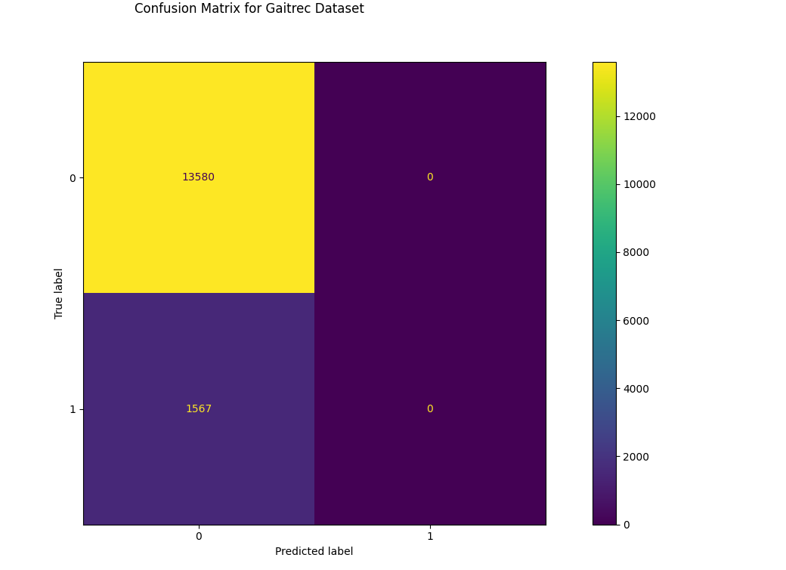

The accuracy report is as shown in the table below:

Accuracy: 0.90

precision recall f1-score support

0 0.90 1.00 0.95 13580

1 0.00 0.00 0.00 1567

accuracy 0.90 15147

macro avg 0.45 0.50 0.47 15147

weighted avg 0.80 0.90 0.85 15147

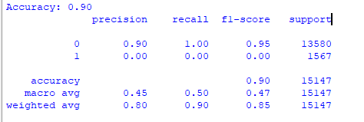

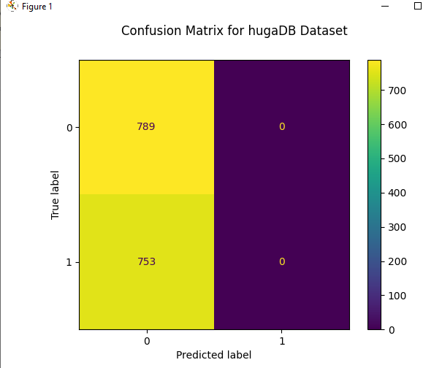

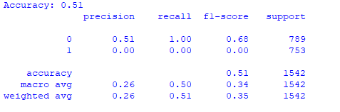

Random Forest

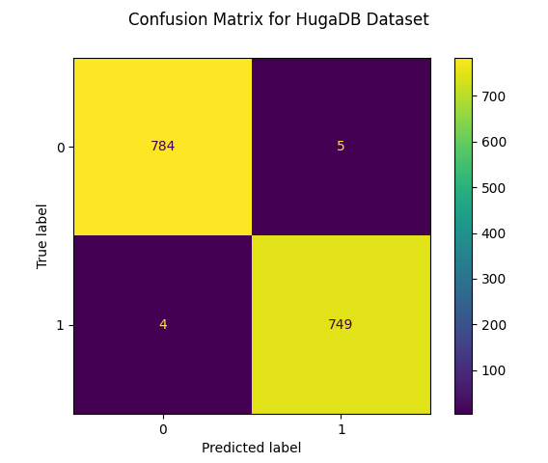

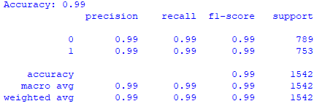

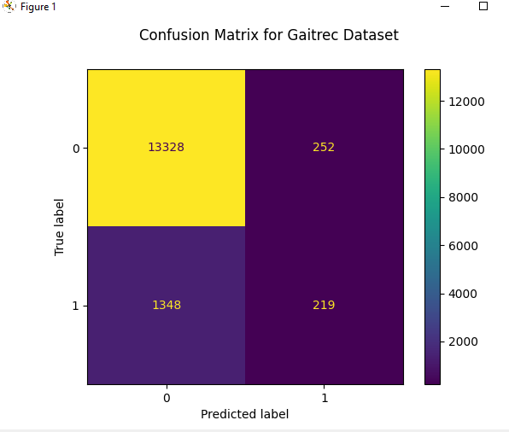

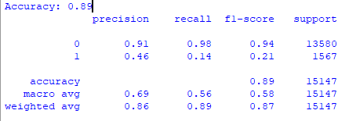

SVM

